

**Application of Deep Learning to Text and Image Data**

Module 1 Lesson 2 Student Guide



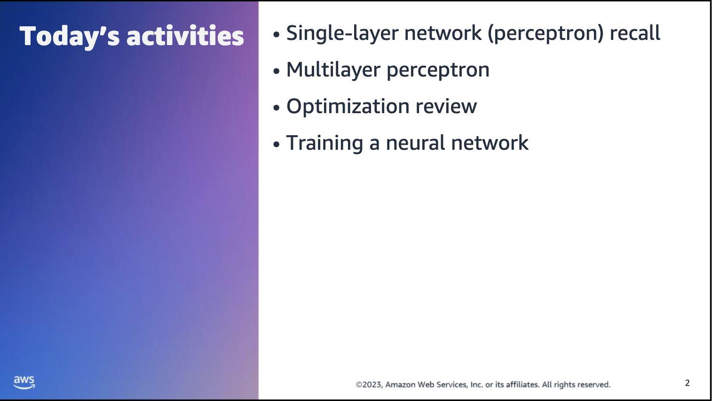



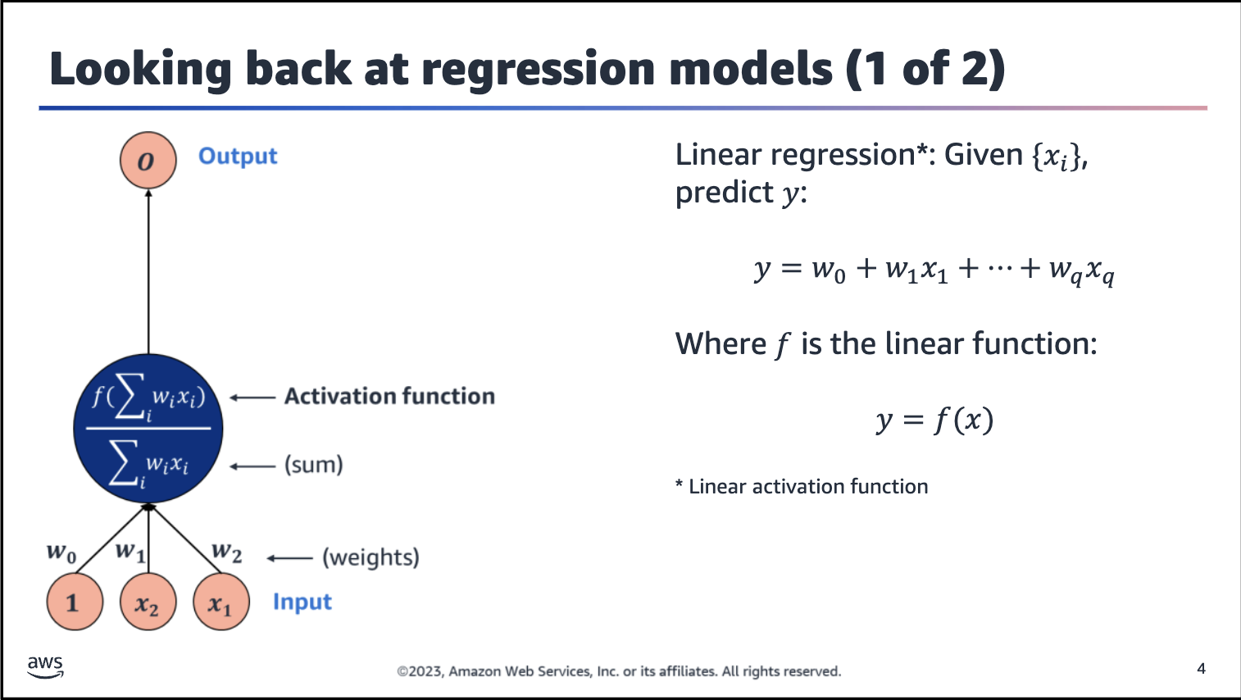

First, consider linear regression from a slightly different perspective. Concentrate on the information flow — or information processing — from input (on the bottom side of the line in the neuron) to output. (on the upper side of the line in the neuron).

Linear regression assumes a linear relationship between input variables (such as x1 and x2) and the single output variable (y), as shown by the linear regression equation on the slide.

With a diagram, you can visualize what happens. Given some inputs (two are shown here for simplicity: x1 and x2, along with the bias, 1):

• Linear regression takes the inputs; weights them accordingly by weights w0, w1, and w2; sums the weighted inputs; and examines the weighted sum. Linear regression then passes that sum along to the output, O.

• If this output doesn’t match the target value, y, then — based on how large the error y-output is — the weights w0, w1, and w2 are adjusted to make the linear regression produce outputs that are closer to the target value, which reduces the error.

• This is done several times until better w0, w1, and w2 are learned from the training data. This provides you with a more reliable model that you can use (trust) later for prediction.

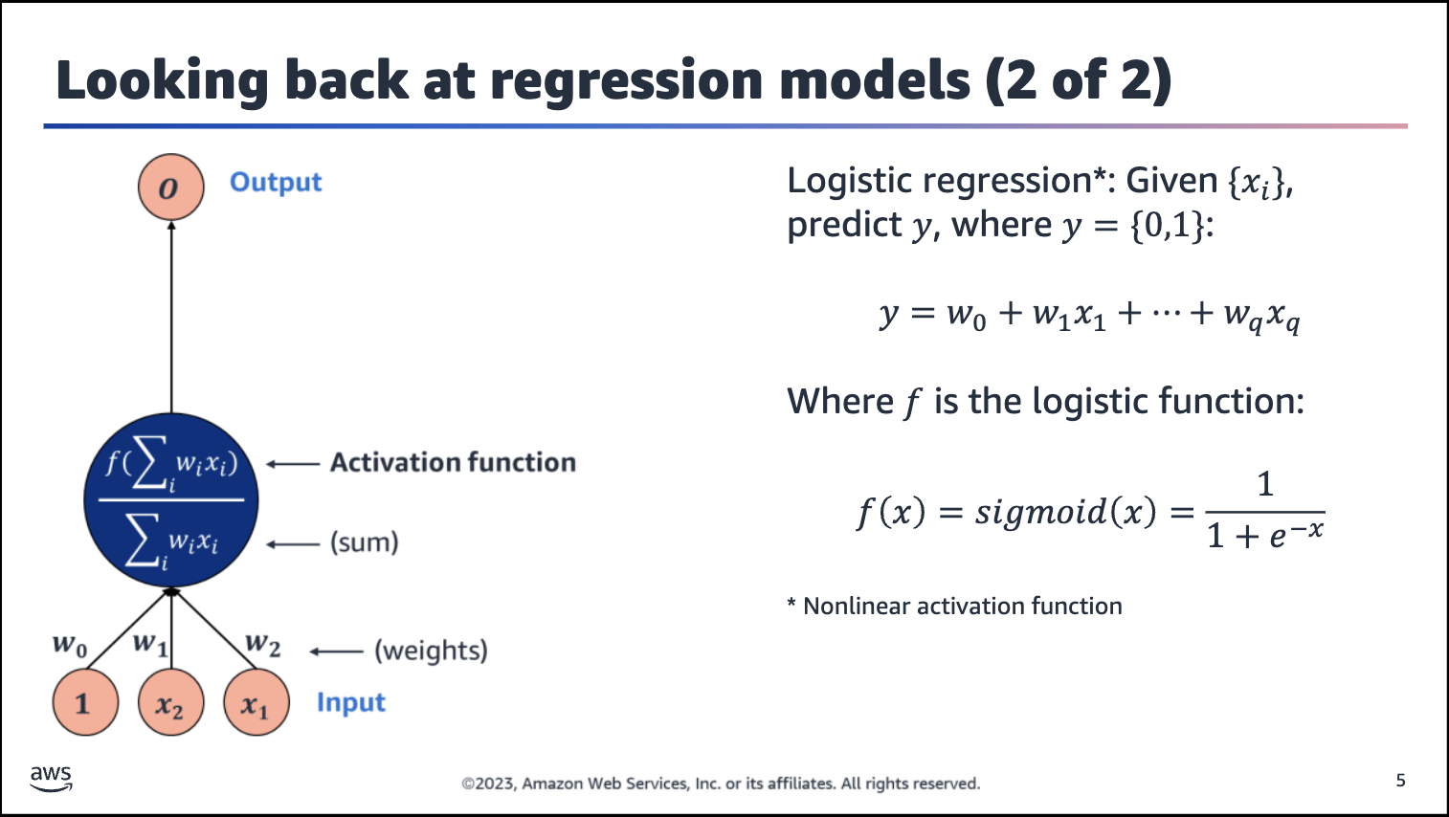

You can do the same thing with logistic regression by using the sigmoid function instead of a linear function.

The neuron represents a logistic regression model that is suitable for binary classification tasks.



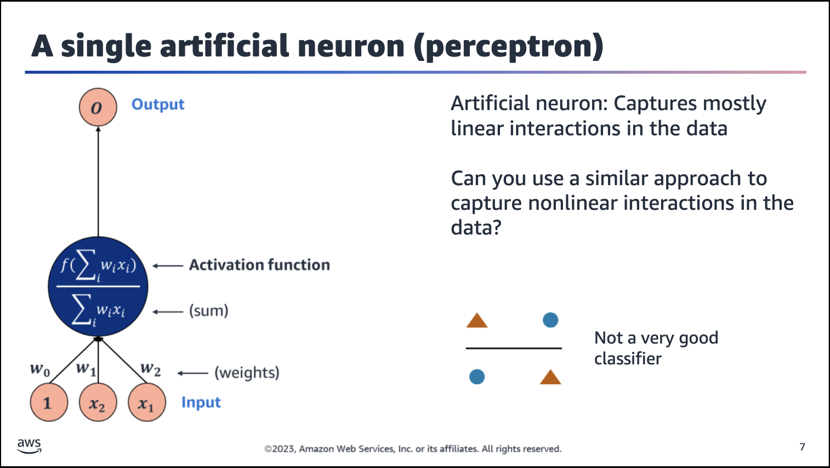

Image description: Markers are placed at the corners of an imaginary square. Moving clockwise from the top-left, the markers are triangle, circle, triangle, circle. The circles are diagonal from each other, and the triangles are diagonal from each other. A

horizontal line passes through the space between the upper and lower markers. The line is not a good classifier because half the points are identified incorrectly on either side of the line.

How can you go beyond one unit (one neuron)? And why would you do so?

As mentioned, a limitation of the artificial neuron is that it captures mostly linear interactions in the data. Can you use a similar approach to capture nonlinear interactions in the data?

For example, consider the traditional XOR problem*. Give four XOR data points — blue circles and orange triangles — separate the blue inputs from the orange inputs by using the concept of an artificial neuron.

*A XOR problem involves using a neural network to predict the outputs of XOR logic gates given two binary inputs. An XOR function should return a true value if the two inputs are not equal and a false value if they are equal.

The artificial neuron that is shown on the left side of the slide is only capable of separating data with a single line. Unfortunately, the XOR data points cannot be separated linearly; that is, any line that you would consider would not completely separate the blue circles from the orange triangles.

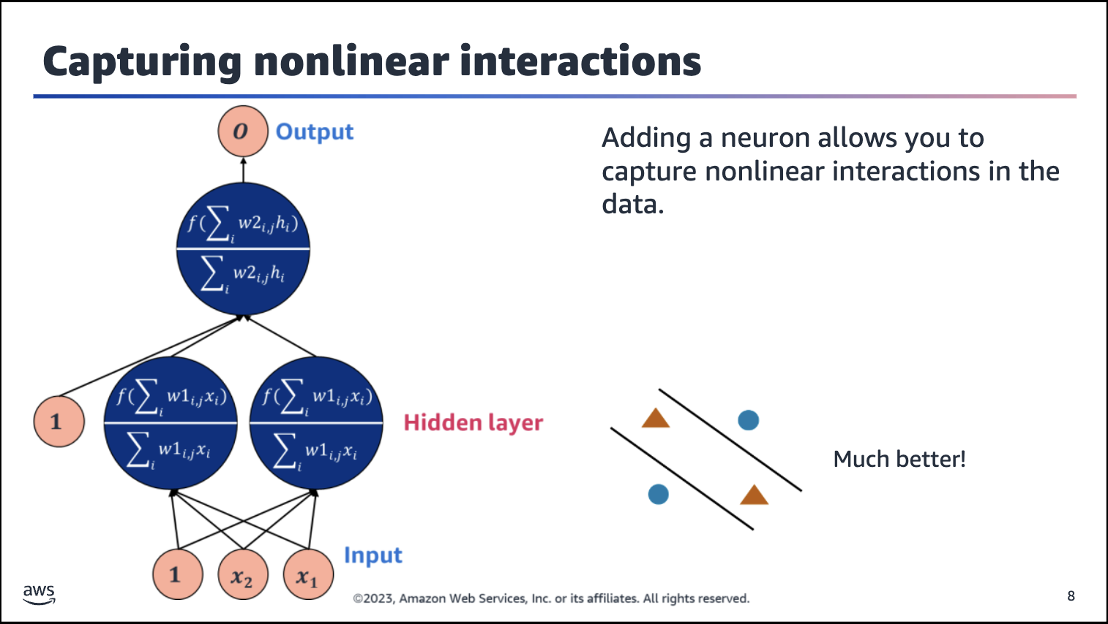

Image description: Markers are placed at the corners of an imaginary square. Moving clockwise from the top-left, the markers are triangle, circle, triangle, circle. The circles are diagonal from each other, and the triangles are diagonal from each other. Two diagonal lines are drawn in the space between the circles and triangles to separate the triangles into the same region, with each circle in its own region. This is a much better classifier.

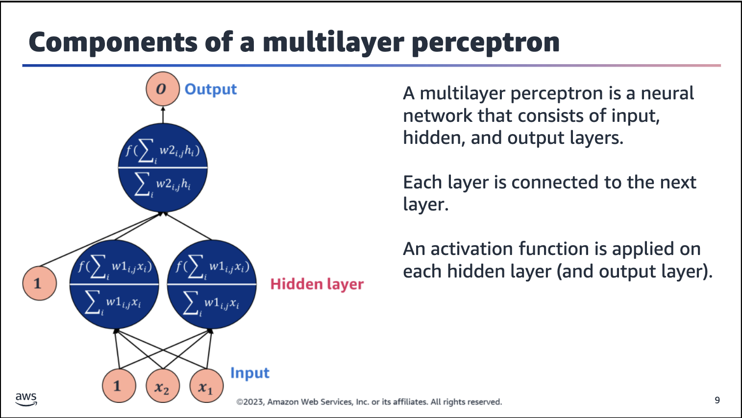

Input layer: This is the first layer in a neural network, and it receives the input data. The number of neurons in the input layer is determined by the number of features in the input data.

Hidden layer: These layers come after the input layer but before the output layer. They are called hiddenbecause their internal workings are not directly visible from the outside. The hidden layers are responsible for learning and abstracting features from the input data. These layers allow the network to discover nonlinear relationships between the inputs and the outputs.

Output layer: This is the last layer in a neural network, and it produces the network’s output. The number of neurons in the output layer is determined by the number of classes or outputs in the problem that you are trying to solve.

The number of layers and neurons in a neural network can vary depending on the problem, data, and architecture.

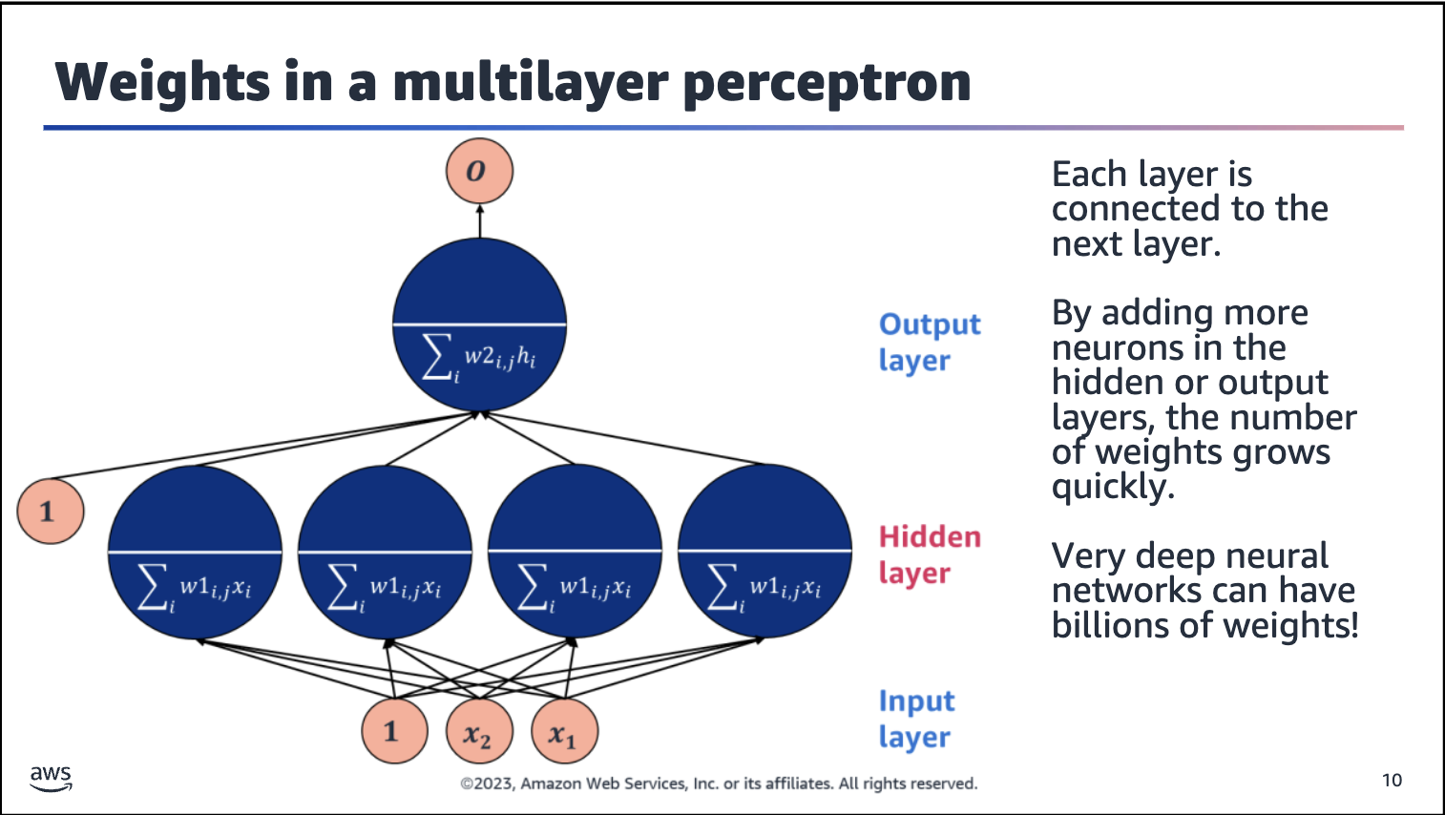

Adding more neurons in the hidden or output layers makes the number of weights grow quickly.

For instance, the neuron on the previous slide has one hidden layer with two neurons and an output layer with one neuron. The network is fed with an input of dimension 3 (two features and a constant, 1, for the bias term). Each connection indicates a weight or parameter of the neural network. Hence, the hidden layer has 2x3 weights (the number of hidden neurons x the input dimension). The output layer has 1x3 weights (the number of output neurons x the input dimension for the output layer). The total number of weights is (2x3) + (1x3) = 9.

Similarly, the number of weights of the neural network that is shown on this slide can be calculated as follows: Number of weights = (4x3) + (1x5) = 17.

Adding layers as well as neurons in each layer rapidly grows the number of weights. While more layers in the network and more neurons in a layer improve the representation power of the network, they can also increase training time, and inference or prediction time.

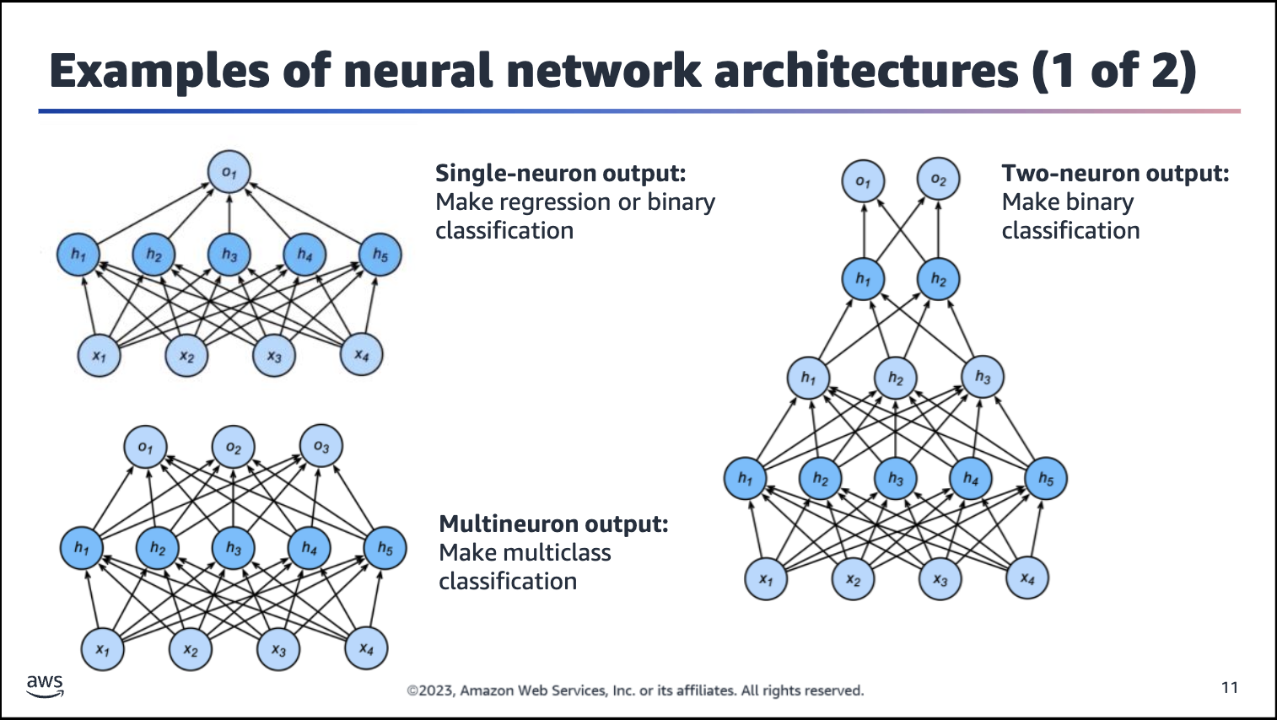

Having a network with two neurons in one hidden layer is still not particularly useful for most real-life ML applications. Typically, you would use more complex neural networks to approximate more complex functions that cannot be easily described by traditional methods.

The trick is to design or engineer a network architecture for the current task. For a more complex binary classification problem, you could design something like the single-neuron output architecture or two-neuron output architecture that are shown

on the slide. These architectures would result in more patterns being learned from the data, which will allow the model to do a better job of separating the two classes):

• The single-neuron output architecture at the top-left of the slide has five neurons in the hidden layer and one neuron in the output layer.

• The two-neuron output architecture on the right side of the slide has four layers, of which three are hidden. The hidden layers have five, three, and two neurons. The output layer has two neurons.

Note: Don’t count the input layer when you consider the total number of layers for a neural network.

Depending on the problem to be solved, the network can go much deeper than four layers. This is where the “deep” part of deep learning comes from — more and more hidden layers make for deeper networks. Deeper networks have more flow and analysis of the information that is received from the inputs to connect to the outputs, which makes for more capable learners altogether.

For example, for a three-class classifier, you could design something like the network on the bottom-left of the slide. This multineuron output architecture has five neurons in the hidden layer and three neurons in the output layer. Each output neuron

generates the probability for each class.

As you might guess, for even more complex tasks — such as high

-dimensional tabular datasets, images, or text data — more complex architectures can and have been engineered. Examples include convolutional neural networks (CNNs) and recurrent neural networks (RNNs). CNNs are engineered to better learn from image-like data. RNNs are engineered to better learn from sequential data, which is particularly useful when working with text data.

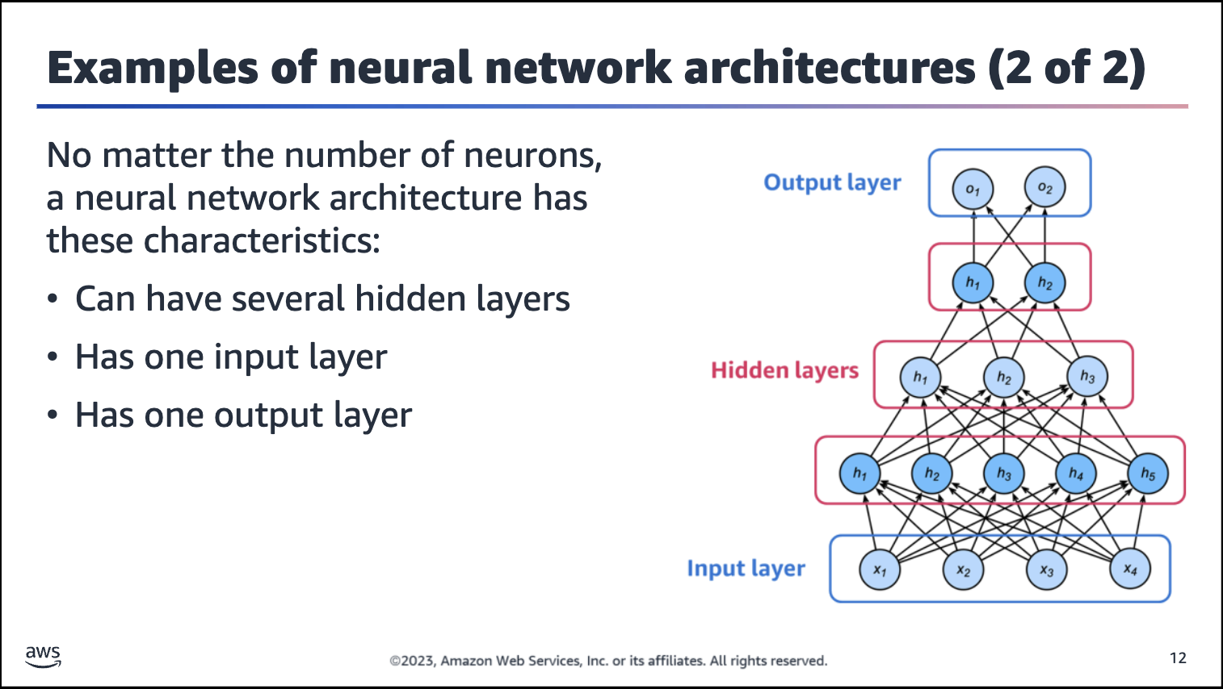



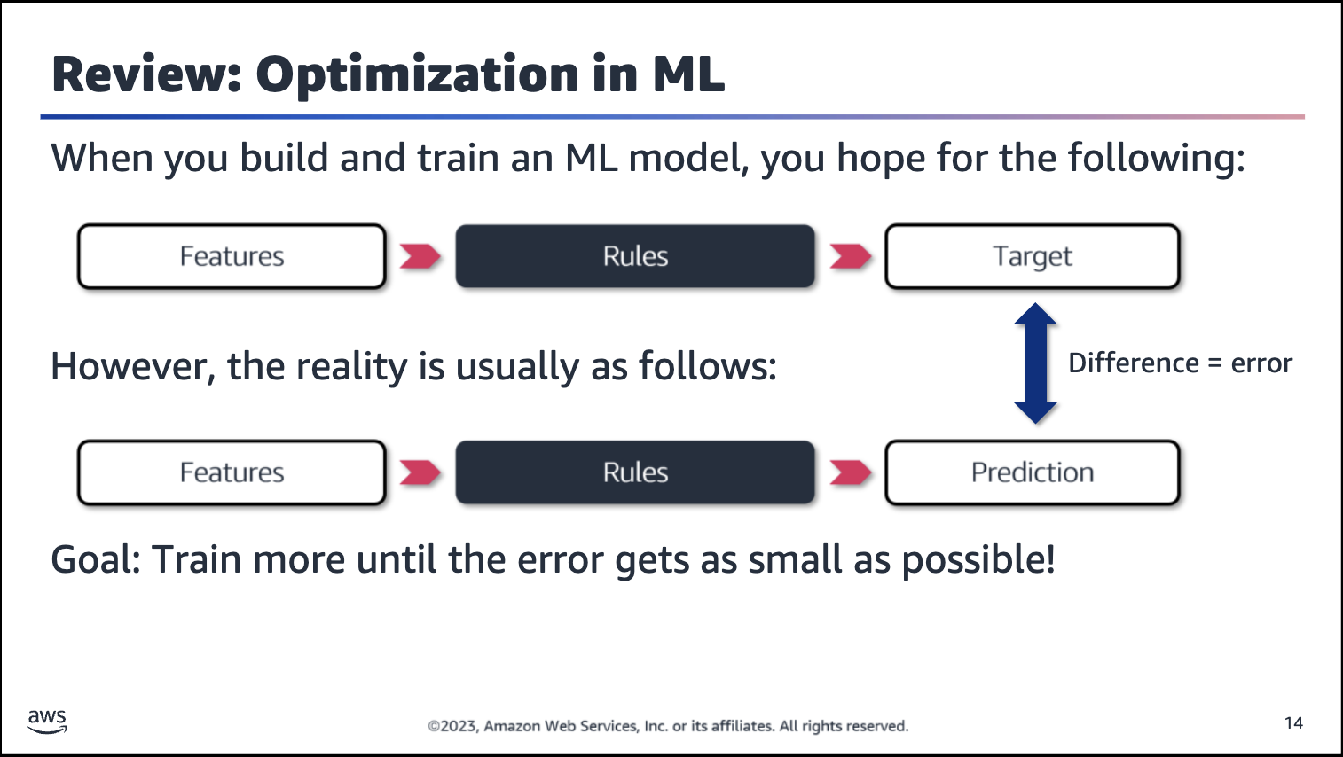

Every ML model aims to take in the model features and match the model target. In reality, almost all ML models take in the model features and make model predictions that rarely match the model target exactly. Some error occurs, which is represented by the difference between the target and prediction values.

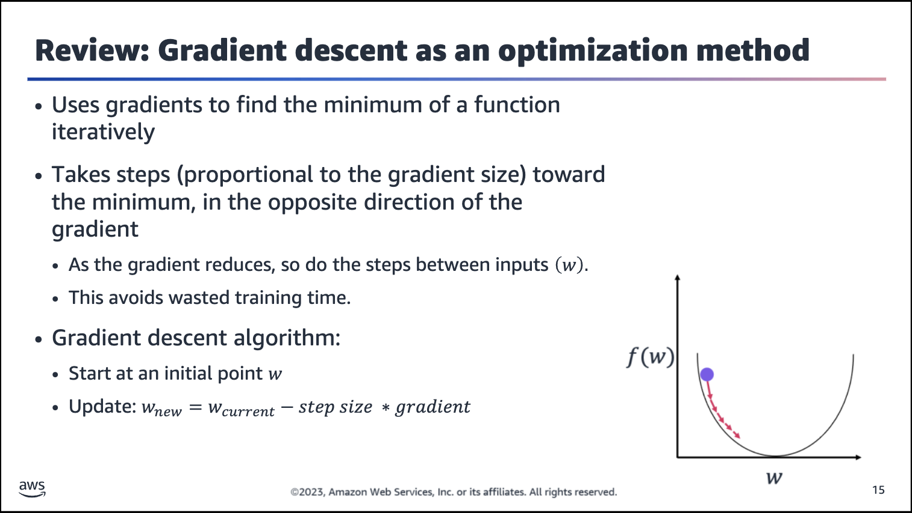

Image description: Diagram of the iterative gradient descent algorithm. The initial weight value is marked, and the weights are updated iteratively toward the optimal value.

Gradient descent algorithm: From any initial point w (presumably not at the minimum so the gradient isn’t zero), move toward the min. Update the w by small or large steps in the opposite direction of the gradient.

The size of the update is controlled by the step size parameter, also known as the learning rate. If the step size is too small, the algorithm might take a long time to converge or might never reach the global minimum.

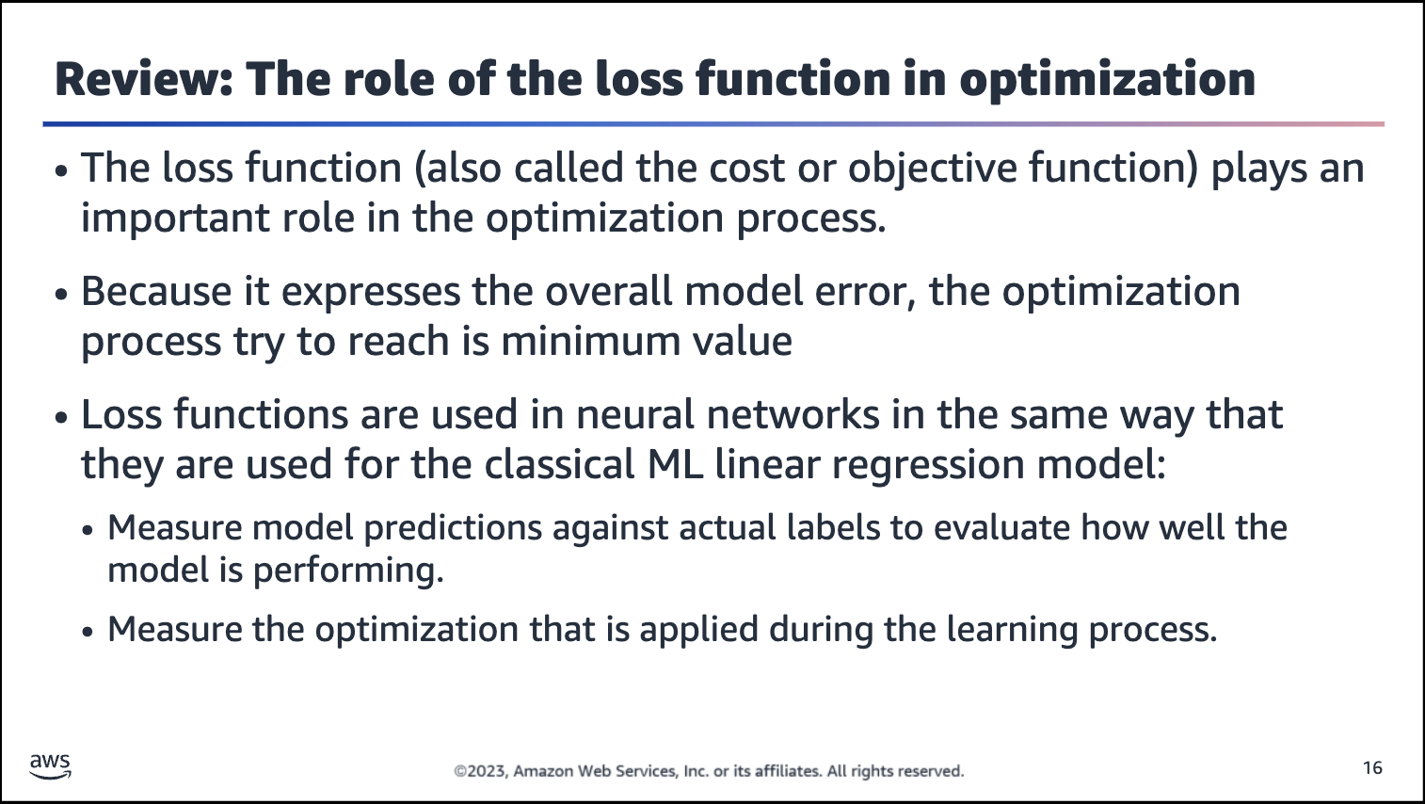

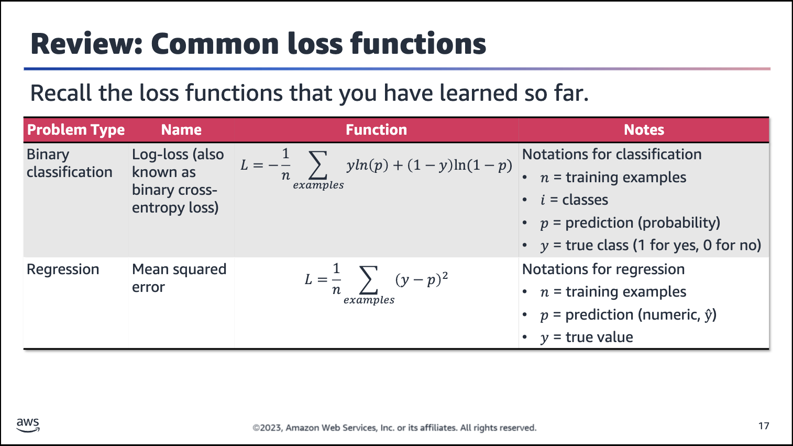

The type of loss function significantly affects the optimization or training of a neural network. The choice of the loss function relates to the task that you are trying to solve.

For binary classification problems, cross-entropy for logistic is a suitable loss function. The term p is the output of the sigmoid activation function, which validates that the problem is binary classification. The loss function can be used to optimize the weights of the network by using gradient descent.

For regression tasks, a metric such as mean squared error is suitable. As required, this loss function is differentiable (meaning

the derivative exists at every point in its domain) and is suitable for predictions and labels that are numerical values.



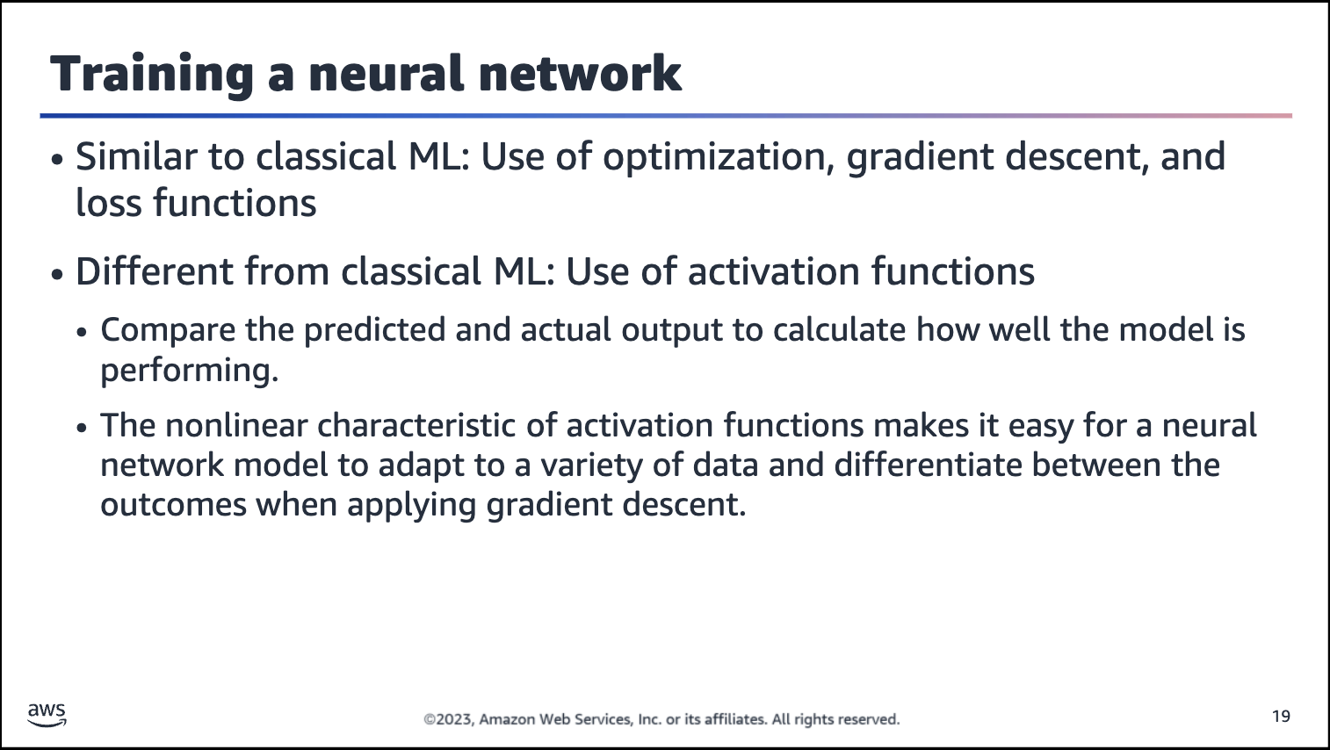

The loss function calculates how well the model is performing by comparing the predicted and actual outputs.

The activation function determines whether to fire (or activate) a neuron in a neural network.

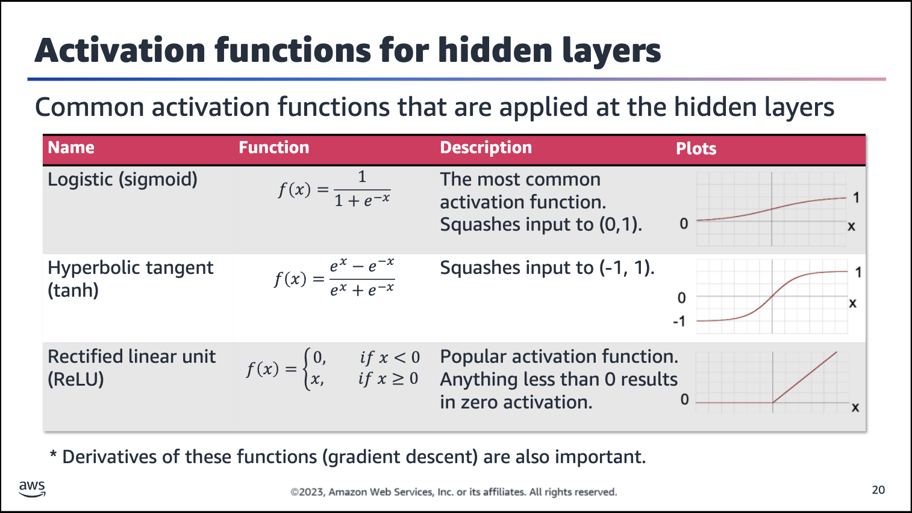

Activation functions are used to analyze, judge, or activate information that comes into the neurons from the weighted inputs. If these activation functions were linear (like identity functions with no activations), then everything would go through the network linearly. The network wouldn’t be able to learn any nonlinear patterns, such as the XOR problem that was discussed earlier in the lesson.

Nonlinear functions are used for activation functions. The flow of inputs through the network with nonlinear activations ensures learning of nonlinear patterns in the dataset. This would not happen with linear activations.

With more neurons and more layers that are equipped with nonlinear activation functions, the whole network will be able to learn more and more complex patterns in the data. Basically, the network can learn more complex nonlinear relationships between the input (features, x) and output (label, y).

For example, as seen with the use of the sigmoid function in logistic regression (which can be thought as a neural network with only one layer and only one neuron in that layer):

• That one nonlinear activation function was a successful decision-making function. It successfully identified a particular pattern (a class, in that case). It answers the question: “Is that simple pattern there or not?”. The probability of the class being

there was mapped between 0 and 1, where 0 meant absence of the feature, and 1 meant its presence.

• The same goes with much larger networks. More neurons are working together, and each is activated by a nonlinear function. Each works to identify whether the pattern is present. Together, they learn more complex patterns than they would separately.

Commonly used activation functions include the sigmoid function, tanh function, and rectified linear unit (ReLU) function.

**Sigmoid function**

• This function is a popular activation. It’s often called a squashing

function because it squashes any real-value input to some value in the range (0, 1). For this reason, in the earliest neural networks, scientists who were interested in modeling biological neurons that fired or didn’t fire started using the sigmoid function as a natural choice for the activation function.

• When attention shifted to gradient-based learning, the sigmoid function was a winner again because it was differentiable with an easy-to-compute derivative.

• Sigmoid functions are still widely used as activation functions on the output units when you want to interpret the outputs as probabilities for binary classification problems. However, the sigmoid function has mostly been replaced by the simpler and more easily trainable ReLU function for use in hidden layers.

**Hyperbolic tangent (tanh) function**

• Similar to the sigmoid function, the tanh function also squashes its inputs but to the (-1,1) range.

• Note that as the input nears 0, the tanh function approaches a linear transformation (as does the sigmoid function).

• Although the shape of the function is similar to the sigmoid function, the tanh function exhibits point symmetry about the origin of the coordinate system (not at 0.5, as with sigmoid).

**ReLU function**

• The rectified linear unit (ReLU) function has been the most popular choice since about 2022

because of the simplicity of implementation and its performance on a variety of predictive tasks.

• The function involves a simple nonlinear transformation.

• It retains only positive elements and discards all negative elements (and sets the corresponding activations to 0).

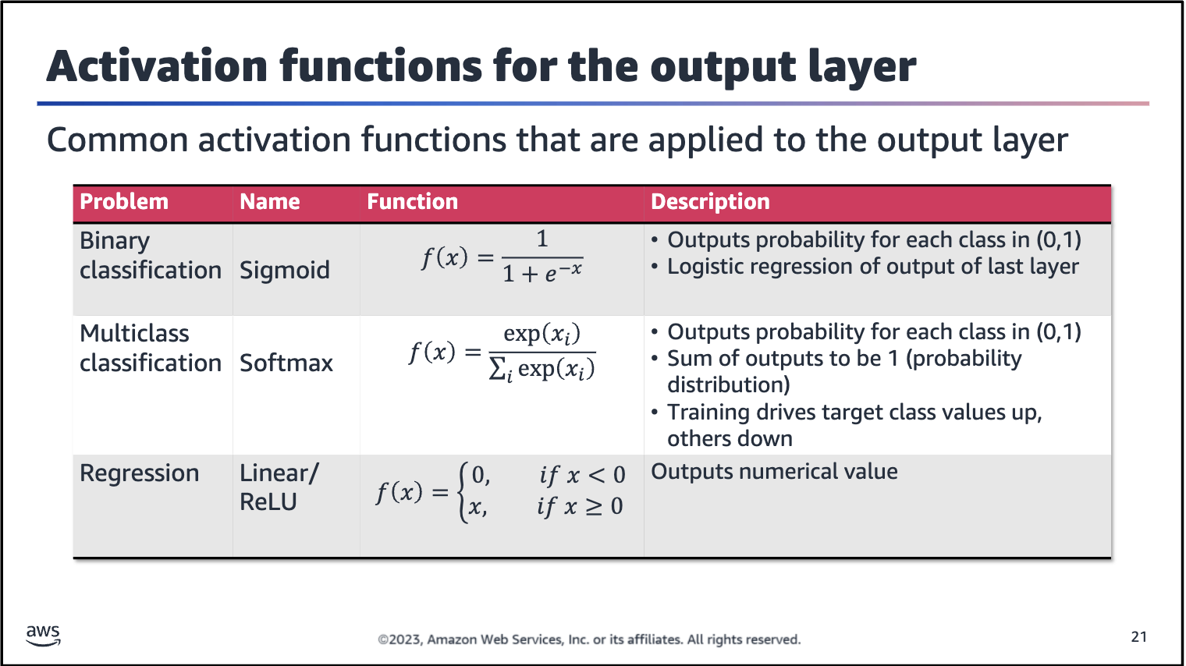

Consider options for output activation functions.

For binary classification problems: The sigmoid function is a good choice because it outputs values in the range (0,1), which can be interpreted as the probability for each class. For example, an output value of 0.89 suggests an 89 percent chance that the data point is class 1 and an 11 percent chance of being class 0.

For multiclass classification problems: The softmax function, which is also known as the normalized exponential function,

extends the sigmoid function to multiclass classification. The function normalizes (scales) the outputs to the range (0,1) and

ensures that they sum to 1. This is what dividing each exponential by the sum of all does here.

For example, if you have a three-class classification problem and three output neurons, softmax outputs from each neuron a value in the range (0,1). One class probability is produced for each class, and the sum of the three probabilities will add up to 1. Out of these three probabilities, the highest decides the final class prediction.

Note: x*i* is the input weighted sum at each neuron — how many classes there are, how many neurons are needed.

For regression: A good choice for an output activation function is the linear function, as seen with linear regression, or ReLU if negative values are not of interest.

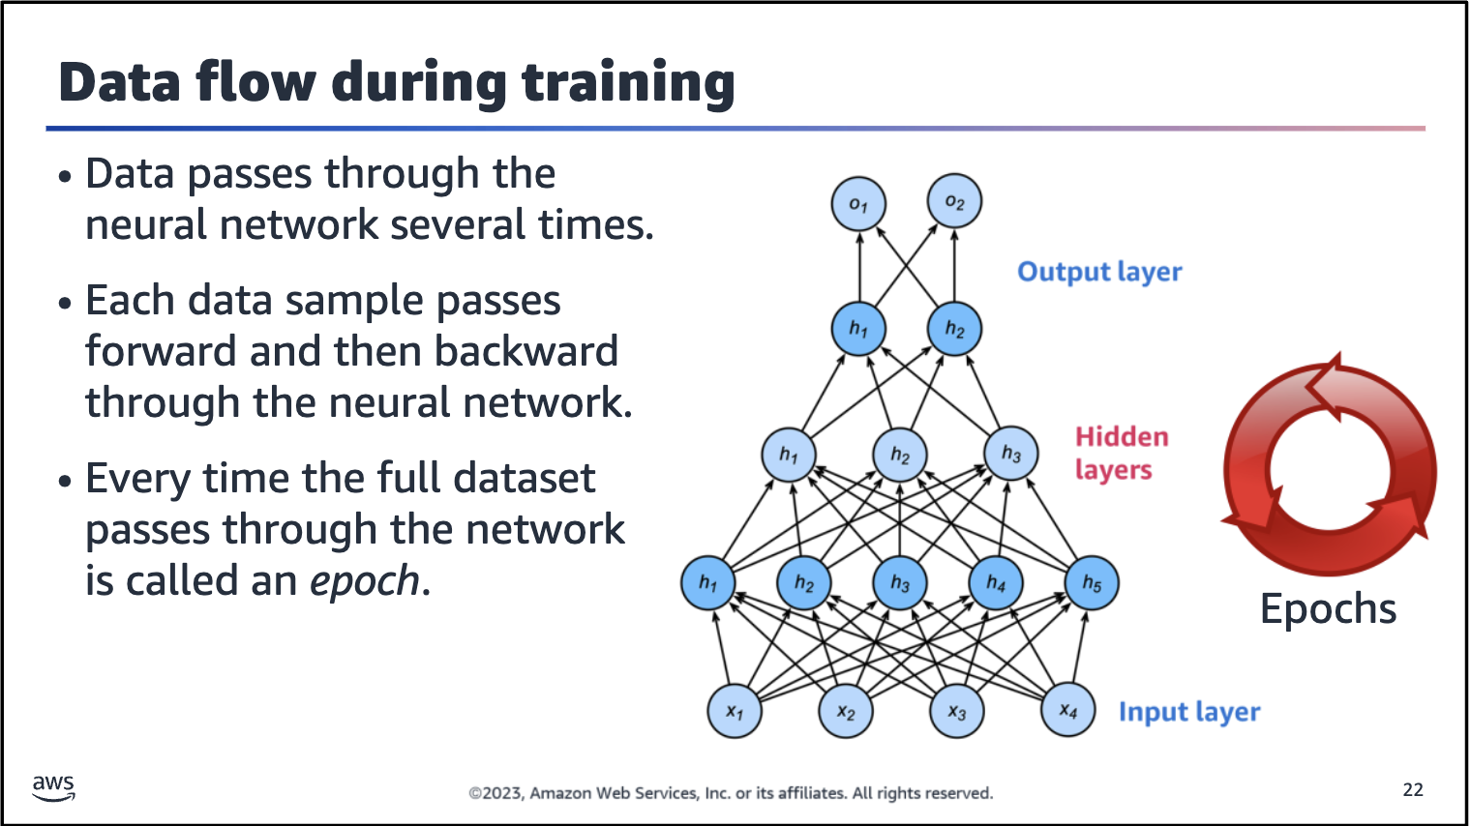

Data flows two ways during training: forward propagation and backpropagation.

Forward propagation: Data flows toward the output layer from the input layer to generate a prediction. The predictions are often used to compute the loss function, which is then used for backpropagation.

Backpropagation: Backpropagation involves computing the loss function from a batch of data and using the gradients to update the weights of the network from the output layer all the way back to the input layer.

Upon iterating over all the samples of a given training dataset for a forward propagation and backpropagation, the network has completed one *epoch*.

.

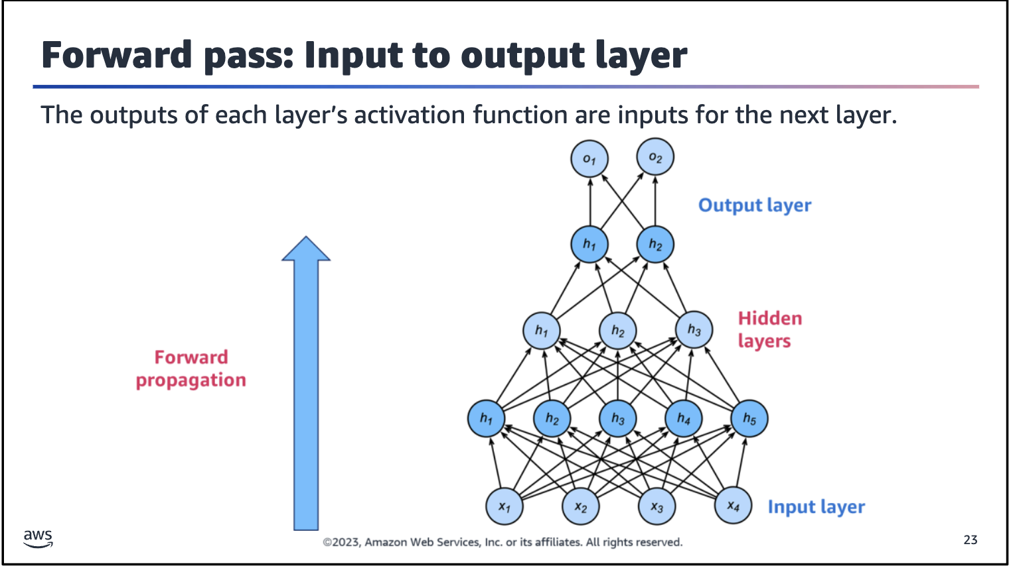

Image description: Illustration of forward propagation. The data goes forward from the input layer to the output layer of the neural network. The activation functions transform the data that goes forward.

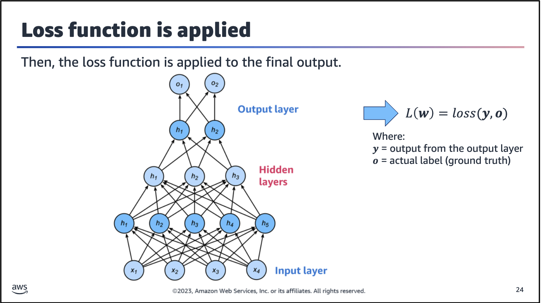

Upon completion of a forward pass, the model predictions are evaluated against the true labels by using a loss function. The loss function is then used to compute the gradient with respect to the weights, which are used during backpropagation.

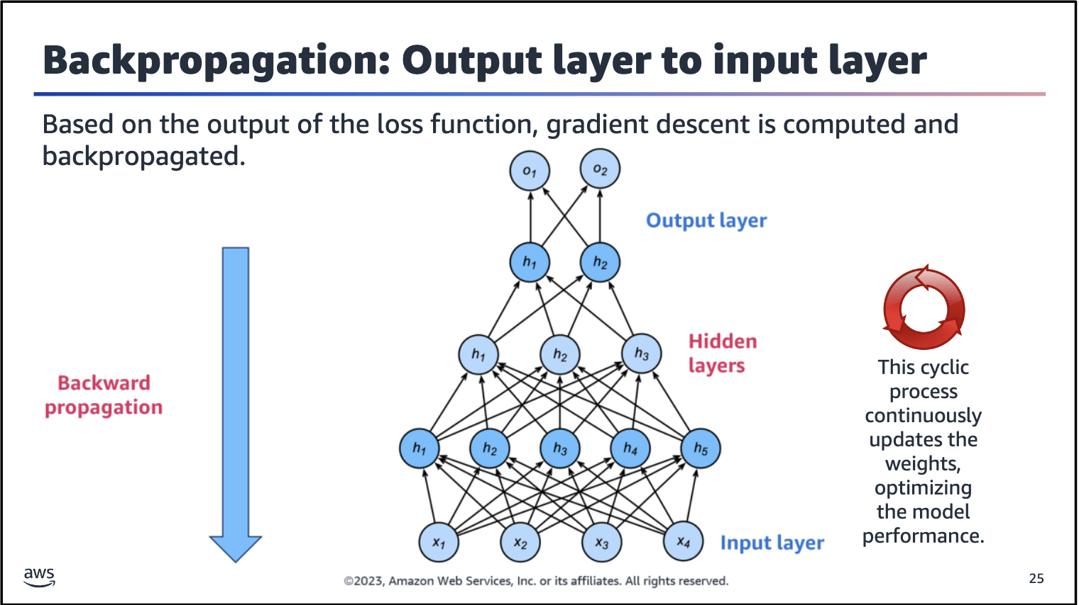

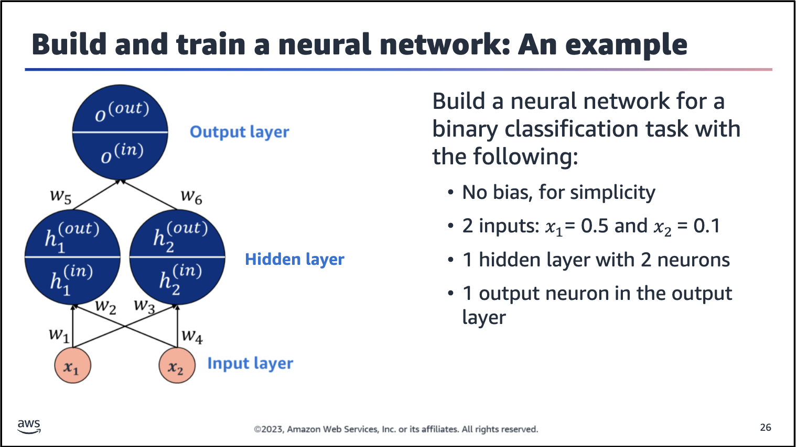

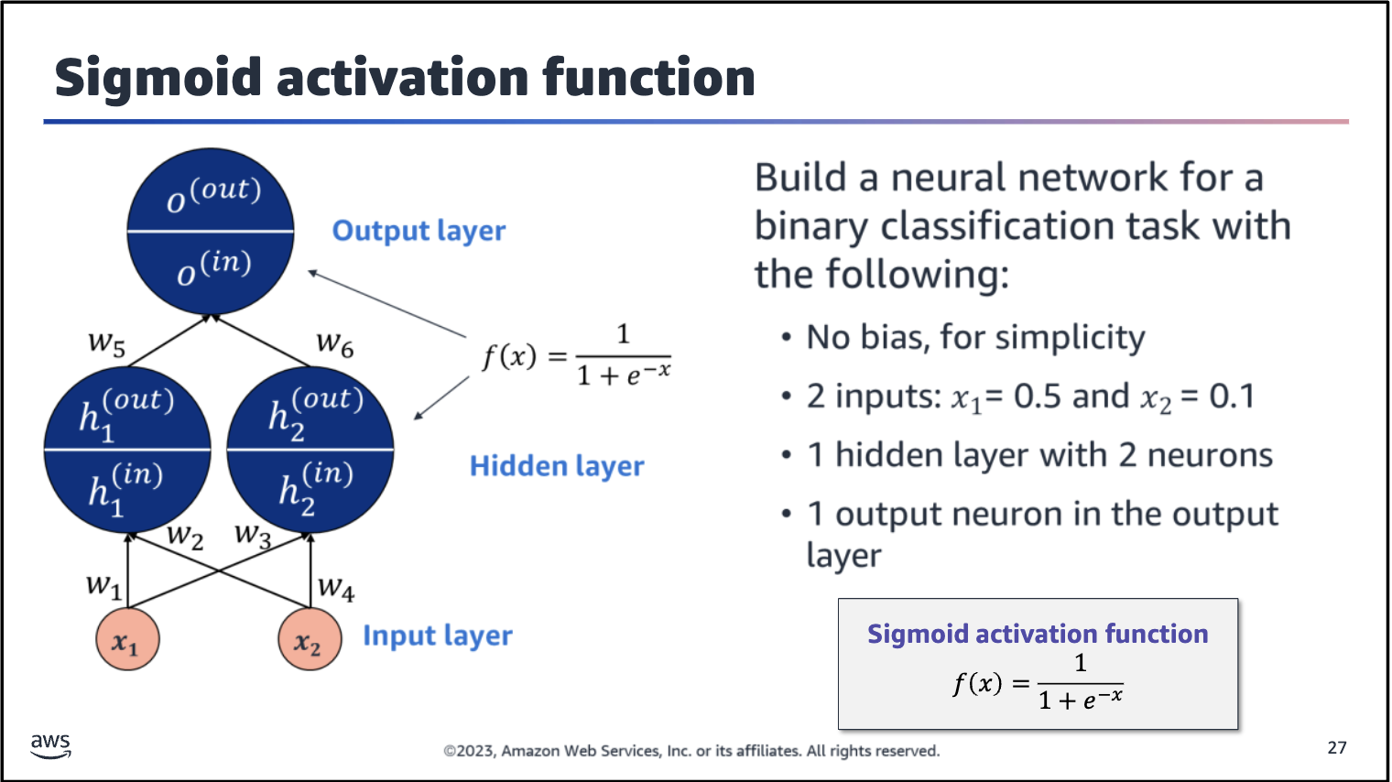

To complete this network, all three neurons use a sigmoid activation function. You can choose different activation or output functions for different layers. However, all neurons in the same layer will use the same activation. The activation functions are

also hyperparameters of the neural network and need to be tuned by using a validation set to identify which choices perform best.

To stay organized and to make it easier to follow the computations, notice the notations in this diagram. The hidden neurons are labeled as h1 and h2, and the output neuron is labeled O. Each one has their own upper scores (in) and (out) to

represent the incoming and outgoing values at that neuron.

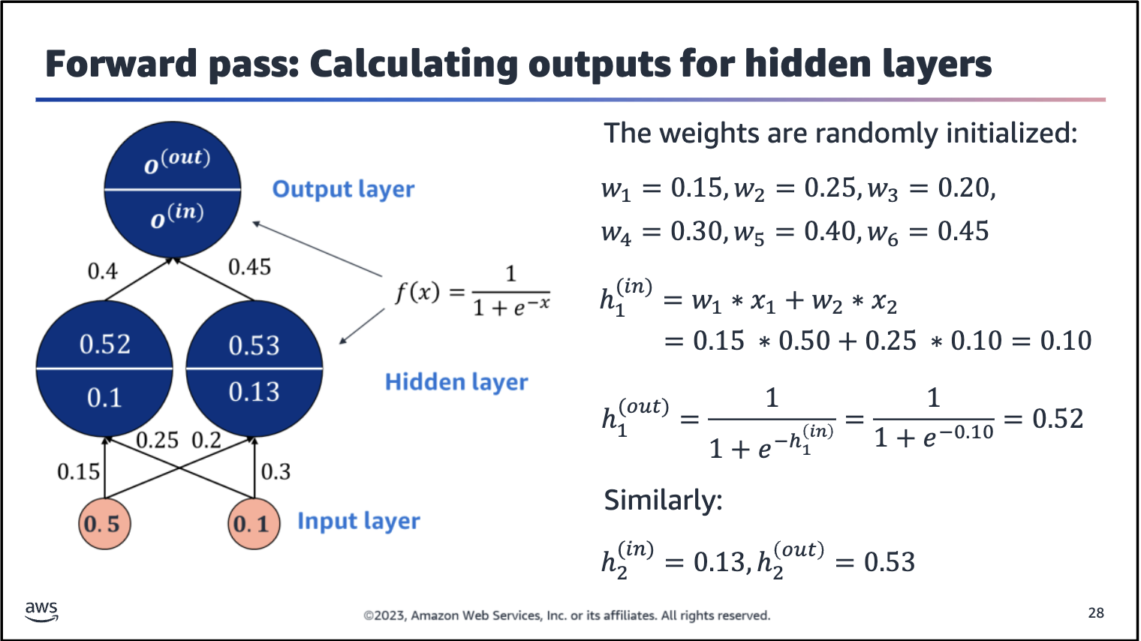

Consider an example where x1=0.5 and x2=0.1. To pass these inputs forward through the network, you need to start with initial values for all six weights. This is traditionally called initializing the network. You need to start somewhere, so you guess, and if that guess isn’t correct, you adjust as needed. Similar to the activation

and output functions, you can choose from popular ways to initialize neural networks or create your own.

The slide lists initial values for the weights, w1 thru w6. Now you have what you need to push the two inputs through the network and compute the network’s output based on those two inputs. The process is as follows:

1. Move from the input layer to the hidden layer.

2. With the inputs 0.5 and 0.1, the weighted sum arrives at the first hidden neuron, h1. The following is calculated: h1(in) = 0.15*0.5 + 0.25*0.1= 0.1.

3. This weighted sum is then transformed by the sigmoid activation function into 0.52.

4. Similarly, with the inputs 0.5 and 0.1, the weighted sum arrives at the second hidden neuron, h2. The following values are calculated: h2(in) = 0.13 and h2(out) = 0.53.

These output values from the first layer, 0.52 and 0.53, will be the inputs to the next layer’s neuron.

One more pass forward through the neural network is needed. (Imagine how, in deeper networks, this might mean that training goes for much longer.)

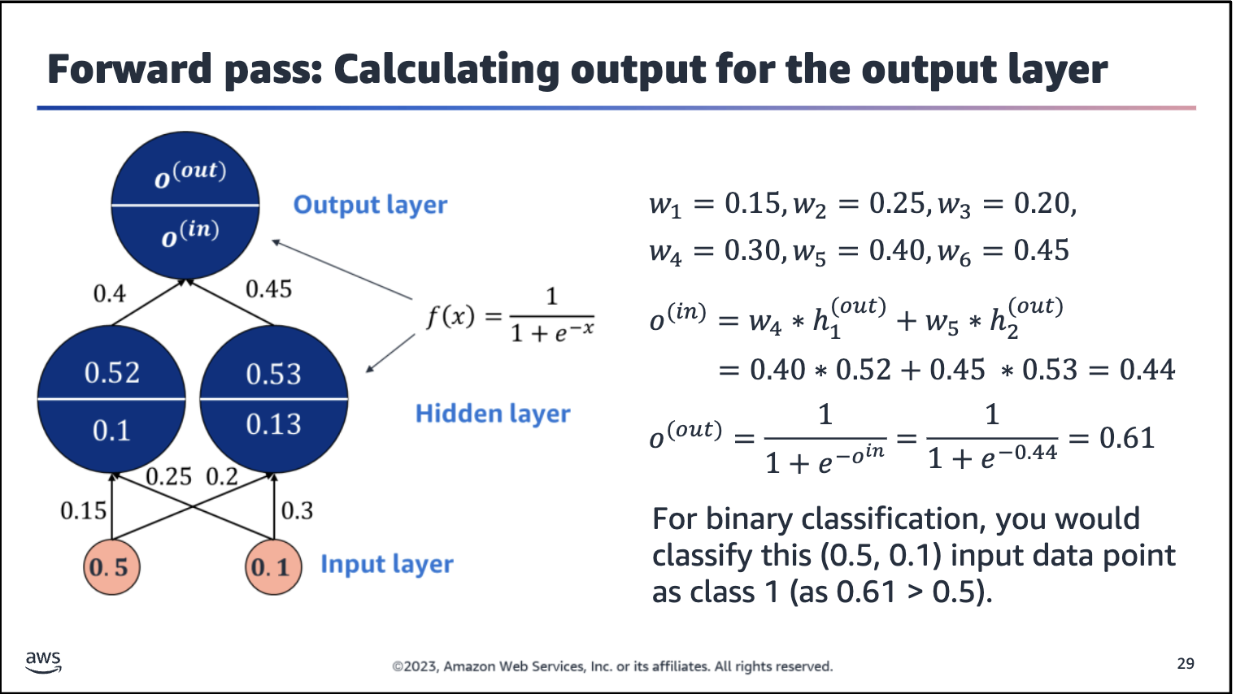

First, to compute the weighted sum that is arriving at the output neuron, use the inputs that are coming from the hidden neurons: o(in) = 0.52*0.4 + 0.53*0.45= 0.44.

The weighted sum is then transformed by the sigmoid activation function to 0.61. This is the final output of the neural network. By using a decision boundary at 0.5 for binary classification, this would be classified as class 1 (because 0.61 > 0.5).

If the true class of the (x1, x2) = (0.5, 0.1) inputs is 1, you would be lucky because you build a good network on the first try. However, most of the time, the first model (neural network) that you build won’t be right.

If the output didn’t match the target, given this neural network architecture, all six of the weights would need to change such that the error between the output and target gets smaller.

You can use gradient descent to move the model in the opposite direction of the error’s gradient, one step at time, to minimize the model’s error.

But how do you compute this error function so that you can then adjust the model (weights) accordingly?

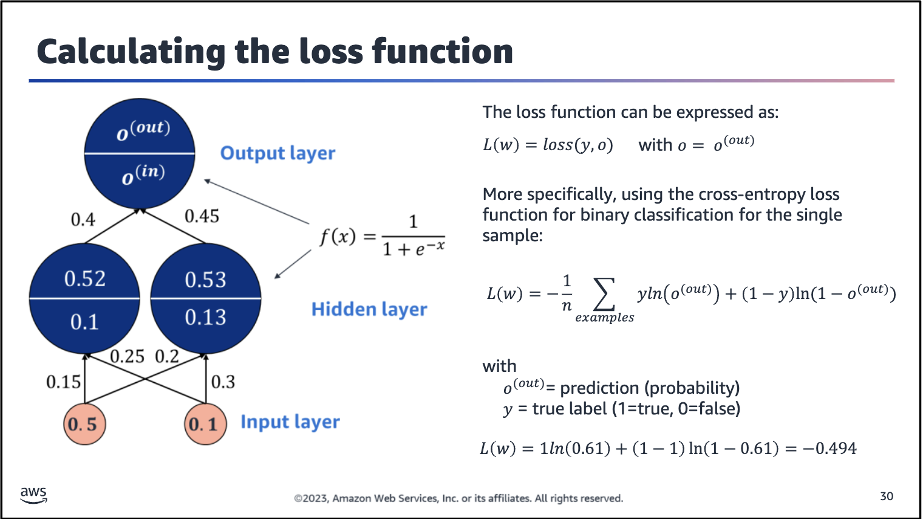

Now that the model has completed forward propagation and generated a prediction, you need to evaluate the predictions. The loss function evaluates the model predictions (o) against the true labels (y).

Because this example describes a binary classification problem, a suitable loss function is cross-entropy loss. By using the predictions, the loss function computes the loss to be -0.494.

